2019“感知中国—共话海上丝路”在华留学生科学论坛
Doctoral Forum: Experiencing China – Dialogue on the Maritime Silk Road
报名表 | Application Form
（一）基本信息 (Basic Information)
（*required fields）
*姓名  Name |  |  | 照片  Photo
* E-mail |  |  | 照片  Photo
*学校/单位  Affiliation |  |  | 照片  Photo
*研究方向  Primary scientific discipline |  |  | 照片  Photo
*性别  Gender | ☐ Male ☐ Female | *国籍  Nationality
*博士入学年份  Year PhD started |  | *指导老师  Supervisor
*护照号  Passport number |  | *CSC留学生号码  CSC number
*手机号码  Cell phone number |  | 微信号  WeChat ID
*选择参加的分会场议题  Session you would like to submit to: | ☐ 海上丝绸之路与跨区域文明交流（人文历史专题）  Maritime Silk Road and the exchange of civilization across regions (Humanity & history session)  ☐ 河口海岸科学技术与可持续的生态系统（河口海岸专题）  Estuarine and coastal science & technology and sustainable ecosystem (Estuarine and coastal session)  ☐ 合作共赢、建设一个共同繁荣的世界（经贸合作专题）  To build a world of common prosperity through win-win cooperation (Economic and trade cooperation session)

（二）具体需求 (Detailed requirements)
*饮食习惯  Dietary restrictions | ☐ None ☐ Vegan ☐ Halal  ☐ Others, please specify:
*住宿安排  Accommodation | Group accommodation has been booked at Dongtanyue Hotel，No. 1428 Antong Road, Chenjia Zhen, Chongming, Shanghai (崇明东滩悦酒店：上海市崇明区陈家镇安通路1428号)  Would you like to share the room?  ☐ Yes, I agree to share the room with a fellow participant.  ☐ No, and I agree to pay half of the room cost (ca. 150 RMB/night).
*班车安排  Please choose the shuttle bus you plan to take: | October 10th, from ECNU North Zhongshan Road Campus to Dongtanyue Hotel: ☐ Bus A will leave at 13:00 ☐ Bus B will leave at 19:00  October 13th, from Dongtanyue Hotel to ECNU North Zhongshan Road Campus: shuttle bus will leave at 07:30

（三）差旅费资助申请 (Financial support application)
Limited funding is available for travel expenses (2nd class train tickets or equivalent economy flights, and no more than 1,500 RMB/person).
If you wish to apply for support, please indicate the amount requested (in RMB) and provide details.
☐ I am self-funded, or
☐ I would apply for the financial support
Amount requested: RMB
Details:

Note: 1. Please complete the Application Form and submit it together with abstracts to the organizing committee (CSC_MaritimeSilkRoad@ecnu.edu.cn) before 31 August 2019.
2. Please provide a photo for inclusion in the booklet so that we can get to know each other (Optional).
3. Information requested in this application is treated confidentially.

论坛摘要写作要求 | Abstract guidelines for the forum

一、提交的摘要需要符合并明确属于本次会议的三个议题之一，亦即：
Abstracts must align with one of the following three sub-themes:

议题一：海上丝绸之路与跨区域文明交流 (人文历史专题，召集人：沐涛教授)
Theme 1: Maritime Silk Road and the exchange of civilization across regions (Humanity & history session; Session Convener: Prof. MU Tao)
本议题具体包含：中日韩的东亚文明、以印度和巴基斯坦为代表的南亚文明、以伊朗和埃及为代表的伊斯兰文明、以肯尼亚和坦桑尼亚为代表的东非斯瓦西里文明等。希望与会者在阐述本国或本地区文明特色的基础上，论述其向外传播的情况。
Topics of this theme include: the East Asian civilization represented by China, Japan and Korea, the South Asian civilization represented by India and Pakistan, the Islamic civilization represented by Iran and Egypt, the Swahili civilization in East Africa represented by Kenya and Tanzania, etc. Participants are encouraged to elaborate the characteristic civilization of their own nation and/or region, especially the spreading of this particular civilization.

议题二：河口海岸科学技术与可持续的生态系统 (河口海岸专题，召集人: 张经教授)
Theme 2: Estuarine and coastal science & technology and sustainable ecosystem (Estuarine and coastal session; Session Convener: Prof. ZHANG Jing)
专题将围绕海上丝绸之路沿线国家的河口与海岸生态系统在气候变化与人类活动影响下的可持续发展和适应性管理进行研讨。历史上，海上丝绸之路国家演绎了古代文明的灿烂，其中河口与海岸地区成为连接世界各地的枢纽。现今，河口海岸地区成为在这个星球上受人类活动与气候变化影响最为显著的区域，那里的生态系统的可持续性对人类社会的未来非常重要。
This theme will focus on the estuarine and coastal ecosystem of the countries along the Maritime Silk Road and to discuss the sustainable development and adaptive management with the impact of climate change and human activity. In history, the glamour of the ancient civilization flowed along the Maritime Silk Road, and the estuarine and coastal regions have become the hubs connecting the world. Nowadays, these regions are the most stressed area on this planet that undergoing rapid change following human activity and climate change, and the sustainable ecosystem of those regions are vital to human society.

议题三：合作共赢、建设一个共同繁荣的世界 (经贸合作专题，召集人：杜德斌教授)
Theme 3: To build a world of common prosperity through win-win cooperation (Economic and trade cooperation session; Session Convener: Prof. DU De-Bin)
海上丝绸之路沿线地区，分布着世界上大多数的发展中国家。经济的发展和贸易、投资是第一要务。海上丝绸之路沿线的各国间通过互联互通，促进贸易大繁荣、投资大便利、人员大流动、技术大发展，建设一个共同繁荣的世界。
Most of the developing countries in the world are spread among the regions along the Maritime Silk Road. With regards to economic development and trade, investment is the most priority. The connectivity of the countries along the Maritime Silk Road will greatly facilitate trade, investment, flow of people and technological advances. We should build a world of common prosperity through win-win cooperation.

- 摘要具体写作要求
Specific instruction

- 摘要的主题和内容应针对赴华留学生原所在国家的工作。作者所在单位应包括留学生在华的学习单位和到中国学习之前的国籍所在单位。
The theme and content of the abstract are required to focus on the studies related to student’s country of origin. The affiliation should reflect the student’s current enrollment in China and primary enrollment from his/her country of origin.
- 提交的摘要可用中文或英文写作。
The abstract can be written either in Chinese or English.
- 摘要应该包含研究工作的目的意义、研究方法、研究结果、主要结论，是一篇相对完整的短文。
The abstract should include the purpose and significance of the research work, methods, results, and main conclusions, considered as a relatively complete short article.
- 摘要中应该着重体现出对数据和问题的分析。
The analysis of data and problems should be emphasized in the abstract.
- 摘要还需提交一幅图和一张表格。地图的采用须注意避免因版权或地域争议而导致的纠纷。请确保图的清晰度以便印刷会议手册。表格请采用“三线”的格式。
One figure and one table are required for the abstract. For maps, please avoid copyright infringement or territorial disputes. All figures should be submitted at the desired printed size. For tables, the format of “three-line table” is recommended.
- 请严格按照后文的格式要求提交摘要，以便后续会议手册的编辑。
Please stick to the Abstract Formatting in the following pages, this will assist in the layout for the Program Handbook.

三、论坛专辑的出版
Forum special issue
论坛期望每位参会者在会后将报告整理为篇幅四页的短论文，计划在《华东师范大学学报》（自然科学版）2020年的第2期刊出。
In cooperation with the Journal of East China Normal University (Natural Sciences), this forum is planning to publish a special issue around the forum topics. All participants will be invited to submit a short paper (about four pages) to this special issue (No.2, 2020).

四、摘要格式与模板
Abstract formatting and template

英文版要求 | English abstract formatting
1. The abstract should be in Times New Roman on an A4 page size with 2cm margins.
2. Title: Use capital letters only when the letters or words should appear in capitals – do not capitalize the entire title. The title should be in 18pt font size, bold and center aligned.
3. Authors: List each author, last name first, using superscripts to identify multiple author affiliations. The authors should be in 10.5pt font size and centre aligned.
4. Author affiliations: each affiliation should be listed on a separate line and superscripted to match to author’s names.
5. Abstract: The body of the abstract must be in 10pt font size and must not exceed 300 words.
6. Keywords: 3-5 words, separated by “;”

英文版模板 | English abstract template
Title
ZHANG Shan¹, ZHANG Yong-sheng^{1, 2}, BAI Wei¹, YU Ke¹, LI Si¹

(1. Department of Electronic Engineering, East China Normal University, Shanghai, 200062, China;
2. Department of Computer, Luoyang Technology College, Luoyang, 471003, China)

Abstract： Study on evergreen broad-leaved forest (EBLF) of China started in 1930s and 1940s, flourished in 1950s, was interrupted in 1960s and has revived since 1970s. ……
Keywords： evergreen broad-leaved forests; retrospect; prospect

…………………………………………………………… see Fig.1
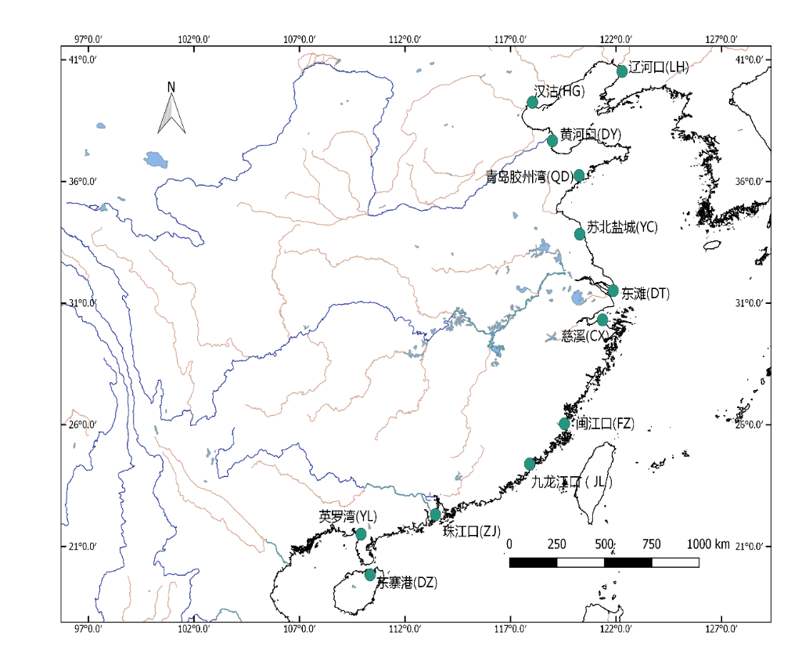
Fig.1 The 12 sampling sites of the study
(Figures must be referred to in the main body of the text, and generally need to be placed below the paragraph where it was first mentioned. Please submit high quality figures at the desired published size.）

…………………………………………………………… see Tab.1

Tab.1 The wave run-up and design crest elevation under current bathymetry and different erosion depths in the 200 year return period
工况 | 低滩高程/m | 平均波高/m | 波周期/s | 波长/m | H_{1%}/m | 波浪爬高/m | 堤顶高程/m
现状 | -0.50 | 1.92 | 6.56 | 47.95 | 3.77 | 2.84 | 10.17
冲深1m | -1.50 | 1.94 | 6.56 | 50.44 | 3.90 | 2.97 | 10.30
冲深2m | -2.50 | 1.94 | 6.54 | 52.44 | 3.99 | 3.06 | 10.39
冲深3m | -3.50 | 1.94 | 6.53 | 54.23 | 4.07 | 3.12 | 10.45
冲深4m | -4.50 | 1.95 | 6.53 | 55.85 | 4.15 | 3.16 | 10.49
冲深5m | -5.50 | 1.96 | 6.53 | 57.32 | 4.21 | 3.20 | 10.53

(Tables must be referred to in the main body of the text, and generally need to be placed below the paragraph where it was first mentioned. The format of “three-line table” is recommended.）

中文版要求 | Chinese abstract formatting
- 摘要请提交word文档，A4页面大小，页边距2厘米，字体采用宋体。
- 摘要题目：四号字体，加粗；居中。
- 作者姓名：小四号字体；居中。
- 作者信息：小五号字体；居中；包括所在单位、所在省市名称及邮政编码。要标明二级单位（大学：院系；研究院所：处、室）。
- 摘要：五号字体；字数300-500字。
- 关键词：五号字体；关键词3～5个，用分号间隔。

中文版模板 | Chinese abstract template
题目
张山¹， 张永生^{1,2}，白薇¹，俞可¹，李四¹
（1.华东师范大学 电子系， 上海 200062； 2.洛阳工业高等专科学校 计算机系，洛阳 471003）

摘 要：首先回顾了起步于20世纪30～40年代的我国常绿阔叶林研究的历史，在此基础上展望了未来的发展. 建议当前需要进一步开展的研究包括……
关键词：常绿阔叶林；回顾；展望

………………………………………………………………………见图1。

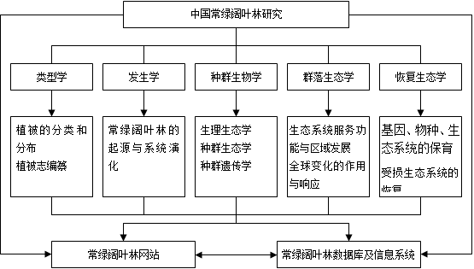
图1 中国常绿阔叶林研究框架图
（插图必须在文中有引用的地方，并且插图一般放在文中首次提到该图处下方。请提供高质量的图片，确保清晰。）

××××××××××××××××××××××。其结果参见表1。

表1 200年一遇设防标准现状地形及不同冲刷深度下的波浪爬高和设计堤顶高程
工况 | 低滩高程/m | 平均波高/m | 波周期/s | 波长/m | H_{1%}/m | 波浪爬高/m | 堤顶高程/m
现状 | -0.50 | 1.92 | 6.56 | 47.95 | 3.77 | 2.84 | 10.17
冲深1m | -1.50 | 1.94 | 6.56 | 50.44 | 3.90 | 2.97 | 10.30
冲深2m | -2.50 | 1.94 | 6.54 | 52.44 | 3.99 | 3.06 | 10.39
冲深3m | -3.50 | 1.94 | 6.53 | 54.23 | 4.07 | 3.12 | 10.45
冲深4m | -4.50 | 1.95 | 6.53 | 55.85 | 4.15 | 3.16 | 10.49
冲深5m | -5.50 | 1.96 | 6.53 | 57.32 | 4.21 | 3.20 | 10.53

（表格必须在文中有引用的地方，并且表格一般放在文中首次提到该表处下方。尽量使用三线表。）

